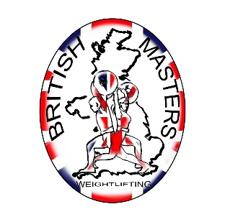 | NORTHERN  Masters Weightlifting Championships.  OFFICIAL ENTRY FORM  RAICH CARTER SPORTS CENTRE, COMMERCIAL ROAD, HENDON, SUNDERLAND SR28PD.  Saturday 16th November 2024.  Weigh-In 8am 9am, Start 10 am.  ENTRY FEE £30.00. |   NORTHERN MASTERS WEIGHTLIFTING

Please complete this form fully and in BLOCK CAPITALS Asterisks denote mandatory fields.
Name*
Address*
 | : | Post Code*
Date of Birth* | / / | Gender*
E-mail* |  | Phone no.

Northern Masters Weightlifting Championships
Body weight category - Please circle (or shade) the correct value *
Men: | 55 | 61 | 67 | 73 | 81 | 89 | 96 | 102 109 +109 | Women: | 45 | 49 | 55 | 59 | 64 | 71 | 76 | 81 87 +87
Total Achieved |  | Club.
Age at 31st December* |  | Age Group*
Age Groups | M35, M40, M45, M50, M55, M60, M65, M70, M75, M80, M85+ and W35, W40, W45, W50, W55, W60, W65, W70, W75, W80, W85+.
I realise I may be tested by the UKADA at the championships and agree to comply with the instructions of the UKADA and Officials. I will not leave the venue until given permission to do so by the relevant UKADA officials or any Designated Authority.
- The closing date for entries is the Saturday 12th October 2024.
- Proof of AGE must be presented at the Weigh-In.
- In submitting this entry form you must pay the entry fee of £30 by the closing date and complete and submit the entry form. If payment is not received by the closing date your name will not go onto the start list.
- This championship will be run according to the IMWLA Masters technical rules.

Payment can be made by cheque, postal order, or bank transfer to Northern Weightlifting Clubs. please indicate by striking through* - Cheque or Bank
Bank transfer to BARCLAYS Bank plc Sort Code 20-11-81 Account No. 30993344 By bank transfer your name must be used as the payment reference to substantiate your entry*.
Mail cheques and/or entry forms to - Chris Baker - 52, Surrey Crescent, Consett, Co Durham, DH8 8HT
Tel: 07849 181705 Email: jcb.cwlc@hotmail.co.uk

I declare that I am physically fit to undertake the sport of weightlifting and have no knowledge of any medical condition which will make weightlifting contra-indicated to my well-being.

Signed ______________________________ Date _______________

Data Protection Act 1984: Information supplied on this form may be held on computer.

