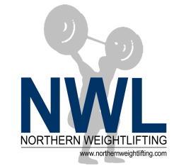 |  | NWL REGIONAL MASTERS WEIGHTLIFTING CONTEST 2019  ENTRY FORM  OASIS COMMUNITY CENTRE, CORONATION ROAD, ELLESMERE PORT, CH65 9AA.  SATURDAY 9th and Sunday 10th NOVEMBER 2019  Weigh-in: 8am-9am Start: 10am depending on numbers - may become 2 days. | 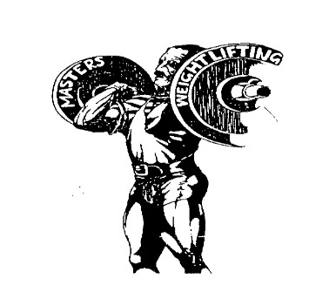
Please complete this form fully and in BLOCK CAPITALS

Name
Address
 |  |  |  |  | Post Code:
Date of Birth. |  |  |  |  | / / |  |  |  |  |  | Gender
Contact Phone No. |  |  |  |  |  |  |  |  |  |  | E-mail
Club Name. |  |  |  |  |  |  |  |  |  |  | BWL Membership No.
NWL Regional Masters
BWT Class - Please circle (or shade) the correct value
Men: | 55 | 61 | 67 | 73 |  | 81 | 89 | 96 | 102 | Women: |  | 45 | 49 |  | 55 | 59 |  | 64 | 71 | 76
 | 109 | +109 |  |  |  |  |  |  |  |  |  | 81 | 87 |  | +87
Age at the 31st December 2019.
Best Total.

- You should note that the closing date for entries is Friday 11th October 2019
- Your BWL Membership Book (or Home Country Membership Card) must be collected at the Weigh-In for the duration of the competition
- Competitors will be notified of any changes to the above details, e.g. weigh in time, start time, etc. Please check the northernweightlifting.com website from 13th October onwards
- With this entry form you must enclose the following:
  - Entry Fee: £23.00
Note: To win a title you must be from the NWL region. Guest lifters from outside of the region will still get a medal but not a placing.

Payment can be made by cheque or by bank transfer. Please tick the box to indicate whether you have paid online or by cheque.
Cheque (made payable to NWL)

Bank transfer to Barclays Bank PLC

Sorting Code - 20-11-81 Account Number - 30993344
When paying online with a bank transfer you MUST put your name and the competition name as the payment reference so that payment can be tracked and entries accepted.
Please return forms and cheque to: Christopher Baker, 52, Surrey Crescent, Consett, Co Durham, DH8 8HT. email jcb.cwlc@hotmail.co.uk Tel no 07849181705.

I agree to be bound by the rules and regulation of the IWF masters and declare that I am physically fit to undertake the sport of weightlifting and have no knowledge of any medical condition which will make weightlifting contra-indicated to my wellbeing.
Signed _________________ Date ________

